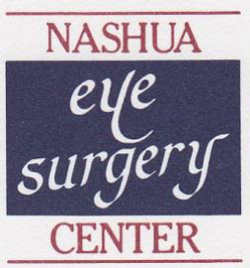
Novamed Surgery Center of Nashua dba Nashua Eye Surgery Center
5 Coliseum Ave, Nashua, NH 03063

This surgery Center is majority owned by Surgery Partners, Inc. at 51%.
The following surgeons have 49% ownership in the Surgery Center:

Nashua Eye Associates:
5 Coliseum Ave. Nashua, NH 03063
Timothy Blake, MD
John Dagianis, MD
Sonalee Desai-Bartoli, MD
Purak Parikh, MD
Faith Birnbaum, MD

Spindel Eye Associates:
6 Tsienneto Road, Suite 101 Derry, NH 03038
Mohamed Guenena, MD

